The Role of Search Engine Optimization

in Digital Marketing

Research Report

COMM-6019-F2023

|  |  |
| --- | --- |
| Group 12 | |
| Gihan Shamike Liyanage  Sachu Divakaran | 1142109  1060332 |

Submitted for: Dr. Edward J. Matthews

Submitted Date: 12/03/2023

Table of Contents

Executive summary 3

The Role of Search Engine Optimization in Digital Marketing 5

Introduction 5

SEO Basics and Evolution 5

Technical Aspects of SEO 6

Impact of SEO on Digital Marketing Strategies 8

Case Studies and Best Practices 10

Future Trends and Innovations in SEO: 11

Key Findings and Recommendations: 12

Conclusion 14

References 15

The Role of Search Engine Optimization in Digital Marketing

# Executive summary

This research report explores the pivotal role of Search Engine Optimization (SEO) in contemporary digital marketing strategies. In an era dominated by online interactions, understanding and mastering SEO have become imperative for businesses aiming to establish a robust online presence and effectively connect with their target audience. This report delves into the basics, evolution, technical aspects, and impact of SEO on digital marketing strategies, offering a comprehensive analysis for both academic and practical insights.

Key Findings:

Understanding SEO: Basics and Evolution:

* SEO is the practice of optimizing online content and websites to improve their visibility in search engine results pages (SERPs).
* The historical evolution of SEO, responding to changing search engine algorithms, highlights its dynamic nature.
* Modern SEO strategies encompass key components such as keyword research, on-page optimization, and link building.

Technical Aspects of SEO:

* Exploration of keyword research and analysis techniques.
* Explanation of on-page optimization methods, including meta tags, headers, and content optimization.
* Discussion of off-page optimization, backlink strategies, and the role of SEO tools and analytics.

Impact of SEO on Digital Marketing Strategies:

* Examination of how SEO enhances website visibility and search engine rankings.
* Analysis of the correlation between effective SEO strategies and increased conversion rates and revenue.
* Integration of SEO with content marketing, social media, and paid advertising.

Case Studies and Best Practices:

* Presentation of real-world case studies showcasing successful SEO implementation in various industries.
* Discussion of ethical SEO practices and common pitfalls to avoid.
* Showcase of examples of innovative and creative SEO campaigns.

Future Trends and Innovations in SEO:

* Exploration of emerging trends such as voice search optimization and mobile-first indexing.
* Discussion of the impact of artificial intelligence and machine learning on SEO strategies.
* Prediction of the future landscape of SEO and its implications for digital marketing professionals.

Recommendations:

* The report emphasizes the critical role of SEO in enhancing online visibility and user engagement.
* Practical recommendations are provided for businesses and marketers to improve their SEO efforts.
* Suggestions are made for further research and exploration within the evolving field of SEO and digital marketing.

This research report not only contributes to academic knowledge but also offers actionable insights for businesses navigating the digital landscape. The findings are drawn from a diverse range of sources, including academic journals, industry reports, case studies, and interviews with SEO experts. The recommendations provided are aimed at empowering businesses to thrive in the competitive digital marketing landscape.

The team eagerly welcomes any inquiries or requests for further details regarding the report. The completion of this research has the potential to benefit both academia and the practical world of digital marketing.

# The Role of Search Engine Optimization in Digital Marketing

## Introduction

In an age dominated by online presence and e-commerce, understanding the significance of Search Engine Optimization (SEO) is paramount for any business striving to thrive in the digital landscape. This research aims to delve into the intricacies of SEO, its impact on digital marketing strategies, and its effectiveness in enhancing online visibility and customer engagement.

Search Engine Optimization (SEO) is the practice of optimizing online content and websites to improve their visibility in search engine results pages (SERPs). It involves various techniques such as keyword research, on-page optimization, and link building to enhance a website's organic (non-paid) search engine rankings. In the digital age, where the majority of consumers rely on search engines to discover products, services, and information, mastering SEO has become paramount for businesses aiming to establish a strong online presence and connect with their target audience effectively. It is a dynamic and multifaceted discipline, evolving alongside search engine algorithms and user behavior, making continuous research, and understanding essential for marketers and businesses.

## SEO Basics and Evolution

**SEO and its Core Principles:**

Search Engine Optimization (SEO) is the strategic practice of optimizing online content and websites to improve their visibility in search engine results. At its core, SEO revolves around the fundamental principle of aligning digital assets with the algorithms of search engines. This involves a nuanced understanding of user intent, relevance, and authority. Keywords play a pivotal role in this process, acting as the bridge between user queries and optimized content. Beyond keywords, SEO's core principles include content quality, website structure, and the cultivation of authoritative backlinks. In essence, SEO is a dynamic and multifaceted approach that seeks to enhance a website's organic search rankings. SEO is not merely a technical endeavor; it is a strategic approach to improve a website's relevance and authority in the eyes of search engines.

**Historical Evolution of SEO in Response to Changing Search Engine Algorithms:**

The historical evolution of SEO is a journey marked by continuous adaptation to evolving search engine algorithms. In the early days, SEO efforts were heavily focused on keyword density and quantity of backlinks. However, as search engines like Google refined their algorithms, the focus shifted towards delivering a more meaningful user experience. The Panda update, for instance, emphasized content quality, while subsequent updates prioritized factors like mobile-friendliness and user engagement. The evolution of SEO is a response to the ever-changing landscape of digital search, requiring marketers to stay agile and align their strategies with the latest algorithmic advancements. Understanding this evolution is crucial for marketers, as it provides insights into the iterative nature of SEO and the need for continuous adaptation.

**Key Components of Modern SEO Strategies:**

Modern SEO strategies encompass a holistic and user-centric approach to online visibility. Key components include:

* Keyword Research and Analysis: Thorough identification of relevant keywords that align with user intent and industry trends.
* On-Page Optimization: Strategic placement of keywords in meta tags, headers, and content, coupled with an emphasis on user-friendly page structures.
* Off-Page Optimization: Building a reputable online presence through high-quality backlinks, social media signals, and influencer collaborations.
* User Experience and Mobile Responsiveness: Prioritizing website design and functionality for optimal user experience, with a specific focus on mobile responsiveness.
* SEO Tools and Analytics: Utilizing a suite of tools and analytics to measure, analyze, and refine SEO strategies based on performance data.

By integrating these components, businesses can not only navigate the complexities of modern SEO but also create a digital presence that resonates with both search engines and their target audience. The key lies in a dynamic and adaptive approach that aligns with the evolving requirements of search engine algorithms and user expectations.

## Technical Aspects of SEO

**Keyword research and analysis techniques:**

Keyword research is the bedrock of effective SEO. It involves identifying and targeting specific terms or phrases that users are likely to enter into search engines. Exploring keyword research techniques requires a deep understanding of user intent, industry trends, and competitive landscapes. Advanced tools, such as keyword planners and analytics platforms, aid in uncovering high-impact keywords. This exploration also involves identifying long-tail keywords, understanding search volume, and assessing the competitiveness of chosen keywords to tailor a strategy that aligns with audience needs.

**On-page optimization methods (Including meta tags, headers, and content optimization)**

On-page optimization is the process of fine-tuning individual web pages to enhance their search engine visibility. This includes optimizing meta tags (title, description), headers (H1, H2, H3 tags), and overall content structure. Proper keyword placement within these elements is crucial for search engines to understand the context of the content. Additionally, content optimization involves creating high-quality, relevant, and engaging content that meets user needs. This ensures that search engines recognize the page as valuable, leading to improved rankings.

**Off-page optimization, backlink strategies, and social signals**

Off-page optimization focuses on activities conducted outside the website to enhance its authority and credibility. A critical aspect of this is backlink building, which involves acquiring high-quality links from reputable websites. Effective backlink strategies involve outreach, content partnerships, and guest posting. Social signals, such as social media shares and engagement, are also vital off-page elements. Search engines consider these signals as indicators of content relevance and authority, influencing rankings.

**Role of SEO tools and analytics in optimizing digital content.**

SEO tools and analytics play a pivotal role in optimizing digital content by providing valuable insights and data-driven decisions. Tools like Google Analytics, SEMrush, and Moz aid in keyword tracking, competitor analysis, and performance measurement. They help identify areas of improvement, track user behavior, and assess the effectiveness of SEO strategies. Analytics data informs marketers about the success of on-page and off-page optimization efforts, allowing for continual refinement and adaptation to changing trends.

Understanding these technical aspects of SEO empowers businesses to create comprehensive strategies that go beyond keyword placement. By integrating on-page and off-page optimization techniques with robust analytics, businesses can build a sustainable online presence that resonates with both search engines and their target audience.

**What are SEO tools?**

SEO tools are essential resources that assist in analyzing and implementing strategies to optimize a website's performance in search engines. While several paid tools like Moz, SEMrush, and Ahrefs offer in-depth SEO analysis, there are also valuable free tools available to support your SEO strategy.

**Google Search Console** provides a comprehensive suite of tools for monitoring various aspects of your website's performance. It allows you to track the number of indexed pages, identify security issues, and offers insights to enhance your page rankings.

For keyword research, **Google Keyword Planner** is a valuable free tool. It helps you identify relevant keywords to target in your website content, aiding in optimizing your pages to rank for specific topics.

Whether using paid or free tools, incorporating these resources into your SEO strategy can significantly contribute to the effectiveness of your digital marketing efforts.

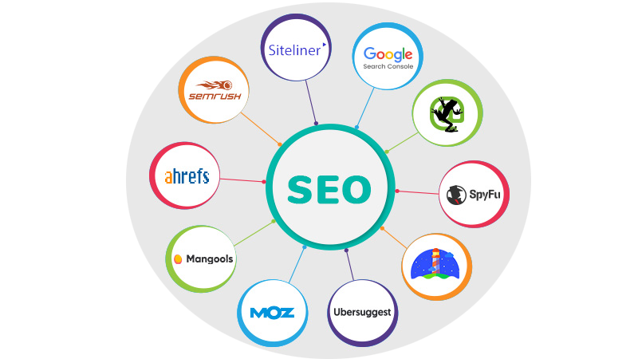

## Impact of SEO on Digital Marketing Strategies

**Benefits of SEO**

* Establish brand awareness.
* Improves website user experience.
* Increase sales through inbound leads.
* Makes website mobile-friendly.
* Increases website speed time.

**How SEO Enhances Website Visibility and Search Engine Rankings:**

SEO serves as a catalyst for enhancing a website's visibility and securing higher rankings in search engine results. By optimizing content with relevant keywords, adhering to search engine guidelines, and fostering high-quality backlinks, SEO ensures that websites are more likely to appear prominently in search results. This increased visibility directly correlates with heightened brand awareness and the potential for attracting a larger, targeted audience.

**Influence of SEO on User Experience, Site Usability, and Mobile Responsiveness:**

SEO has a profound impact on user experience (UX) by necessitating improvements in site usability and mobile responsiveness. Search engines, particularly Google, prioritize user-friendly websites in their rankings. Therefore, SEO practices encourage the creation of seamless navigation, faster load times, and mobile optimization. This not only aligns with search engine algorithms but also enhances the overall user experience, contributing to higher retention rates and user satisfaction.

**Correlation Between Effective SEO Strategies and Increased Conversion Rates and Revenue:**

Effective SEO strategies go beyond visibility and rankings; they directly influence conversion rates and revenue. When a website is optimized for the right keywords and provides valuable content, it attracts users with a genuine interest in the offerings. This targeted traffic is more likely to convert into leads or customers. Analyzing conversion rates in the context of SEO efforts allows businesses to measure the tangible impact of their digital marketing strategies on the bottom line.

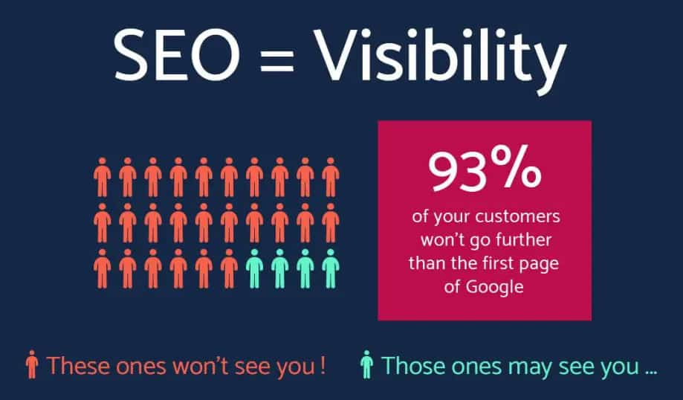

**Integration of SEO with Content Marketing, Social Media, and Paid Advertising:**

SEO does not operate in isolation; its effectiveness is magnified when integrated with other digital marketing channels. Content marketing, for instance, aligns closely with SEO by creating valuable and relevant content that appeals to both users and search engines. Social media signals and engagement contribute to off-page SEO, further establishing authority. Paid advertising, when harmonized with SEO strategies, can maximize visibility in both organic and paid search results, creating a cohesive digital marketing approach.

Understanding and harnessing the impact of SEO on various facets of digital marketing enable businesses to create holistic strategies that amplify their online presence, engage their audience effectively, and drive measurable results. By recognizing the interconnected nature of SEO with other marketing channels, businesses can optimize their digital strategies for sustained success in the competitive online landscape.

## Case Studies and Best Practices

**Real-World Case Studies Highlighting Successful SEO Implementation in Various Industries:**

Real-world case studies serve as valuable insights into the tangible impact of SEO strategies across diverse industries. By examining successful implementations, businesses gain actionable takeaways. Case studies may include instances where targeted keyword optimization led to significant traffic increases, successful content marketing efforts, or innovative approaches to overcoming industry-specific challenges. These examples provide benchmarks and inspiration for businesses looking to optimize their digital presence.

* **The E-commerce Boom Case Study:** Highlighting a modest online clothing retailer, this case study underscores the transformative power of SEO in competing with industry giants. Through meticulous on-page SEO enhancements, product description optimization, and the creation of compelling content, the retailer achieved a remarkable 200% surge in organic traffic and a substantial 150% increase in revenue in just six months. The key takeaway is that, with effective SEO strategies, even smaller businesses can flourish in fiercely competitive markets.
* **Local SEO Domination Case Study:** Examining the experience of a local bakery navigating a saturated market, this case study illuminates the impact of local SEO strategies. By refining their Google My Business listing, cultivating positive reviews, and strategically targeting local keywords, the bakery witnessed an impressive 300% surge in online inquiries and a significant 50% growth in foot traffic. The lesson here is that for brick-and-mortar businesses, mastering local SEO can be a game-changer.
* **Content is King Case Study:** Centered around a content-driven blog in a niche industry, this case study delves into how superior, SEO-optimized content propelled the blog to authority status. Over time, the blog garnered a substantial and engaged audience, leading to lucrative partnerships and advertising deals. The core message is that a commitment to producing consistent, valuable content can pave the way for enduring SEO success.

**Ethical SEO Practices and Common Pitfalls to Avoid:**

Ethical SEO practices are foundational for sustainable success. Discussing these practices involves emphasizing transparency, honesty, and adherence to search engine guidelines. This section should also address common pitfalls to steer clear of, such as keyword stuffing, cloaking, or engaging in manipulative link-building tactics. By promoting ethical practices and warning against potential pitfalls, businesses can build a solid foundation for long-term success without risking penalties or reputational damage.

**Examples of Innovative and Creative SEO Campaigns:**

Innovation and creativity play a pivotal role in cutting through digital noise. Showcase examples of SEO campaigns that went beyond conventional strategies, such as leveraging interactive content, gamification, or unique social media integrations. These examples demonstrate the ability to capture audience attention and stand out in competitive markets. Innovative campaigns not only enhance visibility but also create memorable brand experiences, fostering long-term customer engagement.

By presenting case studies, ethical practices, and innovative campaigns, businesses can glean actionable insights for their own SEO endeavors. Real-world examples provide tangible proof of the positive impact of ethical SEO practices, helping businesses navigate the complexities of digital marketing with confidence and creativity.

## Future Trends and Innovations in SEO:

**Voice Search Optimization and Mobile-First Indexing:**

**Voice Search Optimization:** With the increasing use of virtual assistants and smart speakers, voice search is becoming more prevalent. Future SEO strategies will need to optimize content for conversational queries, long-tail keywords, and provide concise, direct answers to user questions.

**Mobile-First Indexing:** Google's mobile-first indexing prioritizes the mobile version of a website for ranking and indexing. Websites that are mobile-friendly and offer a seamless user experience on mobile devices will continue to receive preference in search rankings.

**Impact of Artificial Intelligence (AI) and Machine Learning (ML) on SEO:**

In 2022, the emergence of AI has become a game-changer, influencing various workflows, including the way we approach SEO. An illustrative example is ChatGPT's Advanced Data Analysis feature, enabling the upload of keyword lists for analysis. This functionality assists in identifying keywords worth pursuing and aids in brainstorming long-tail keywords and potential blog topics to enhance competitiveness. Moreover, major search engines like Google are gearing up for substantial changes, integrating AI into the search experience. This shift is set to reshape our strategies for approaching SEO, emphasizing the growing role of artificial intelligence in the evolving landscape.

**Algorithmic Changes:** Search engines are incorporating AI and ML into their algorithms to better understand user intent, context, and content relevance. SEO strategies need to adapt to these algorithmic changes by focusing on user-centric content and context.

**Personalization:** AI enables more personalized search experiences. SEO professionals will need to leverage data and AI tools to understand user behavior and preferences, tailoring content and recommendations accordingly.

**Automation in SEO Tasks:** AI can automate routine tasks such as keyword research, content optimization, and performance analysis. This allows SEO professionals to focus on strategic aspects while improving efficiency.

**Future Landscape of SEO and Implications for Digital Marketing Professionals:**

The future landscape of SEO holds several key trends and changes that will significantly impact digital marketing professionals. Understanding and adapting to these shifts is crucial for staying competitive in the dynamic online space. Here are some insights into the future of SEO and its implications for digital marketing professionals:

**User Experience and Core Web Vitals:** Google's emphasis on user experience, as reflected in Core Web Vitals, is likely to become even more critical. SEO professionals must prioritize factors like page speed, interactivity, and visual stability to ensure a positive user experience.

**E-A-T (Expertise, Authoritativeness, Trustworthiness):** Google continues to prioritize E-A-T in its search algorithms. Future SEO strategies will need to emphasize building and demonstrating expertise, authoritativeness, and trustworthiness through content and online presence.

**Visual and Video Search:** As visual and video content becomes more prevalent, optimizing for visual and video search will be crucial. SEO professionals will need to pay attention to image and video optimization, as well as structured data for better search visibility.

**Blockchain and SEO:** Blockchain technology may play a role in enhancing the security and transparency of online transactions and data. While the impact is still evolving, SEO professionals should stay informed about potential implications for search rankings and user trust.

The future of SEO will be shaped by advancements in technology, changing user behaviors, and the evolving landscape of the digital ecosystem. Digital marketing professionals should stay proactive, adapt to emerging trends, and prioritize user-centric strategies to stay ahead in the dynamic field of SEO. Continuous learning, data-driven decision-making, and agility in response to industry shifts will be crucial for success.

## Key Findings and Recommendations:

**Key Findings:**

SEO plays a pivotal role in enhancing website visibility and search engine rankings, leading to increased organic traffic. The influence of SEO extends beyond search engines, impacting user experience, site usability, and mobile responsiveness. Effective SEO strategies correlate with higher conversion rates and increased revenue by attracting and engaging the right audience. Integration of SEO with content marketing, social media, and paid advertising creates a comprehensive digital marketing strategy.

**Practical Recommendations:**

Implementing these practical recommendations will contribute to a holistic and effective SEO strategy, helping you achieve better visibility, increased traffic, and improved conversion rates.

* **Prioritize Mobile Optimization:** Given the rise of mobile usage, ensure your website is mobile-friendly, providing a seamless experience across devices.
* **Focus on Quality Content:** Develop high-quality, relevant, and valuable content that aligns with user intent. Regularly update and optimize content for search engines.
* **User-Centric Approach:** Design your website and content with the user in mind. Prioritize user experience, and pay attention to factors like page speed, navigation, and accessibility.
* **Stay Informed on Algorithm Changes:** Keep abreast of search engine algorithm updates. Adapt SEO strategies to align with evolving algorithms and industry best practices.
* **Utilize AI and Automation Tools:** Explore AI and automation tools for tasks such as keyword research, content optimization, and data analysis. This can enhance efficiency and provide actionable insights.
* **Build Quality Backlinks:** Earn backlinks from reputable and relevant websites in your industry. Guest posting, partnerships, and content collaborations are effective ways to acquire backlinks.
* **Implement Structured Data Markup:** Use schema markup to provide search engines with additional context about your content. Enhance rich snippets, which can improve click-through rates.
* **Utilize Local SEO Strategies:** Optimize your Google My Business listing with accurate information. Encourage and manage customer reviews on platforms like Google and Yelp.

**Areas for Further Research and Exploration:**

**Local SEO and Hyperlocal Targeting:** Investigate the impact of localized search trends on businesses. Explore strategies for hyperlocal targeting to reach specific audiences.

**Voice Search and Conversational AI:** Delve into the evolving landscape of voice search and its implications for SEO. Research the integration of conversational AI to enhance user interactions.

**Blockchain Technology and SEO Security:** Explore the potential applications of blockchain in ensuring the security and integrity of online information, particularly in the context of SEO.

**Video and Visual Search Optimization:** Investigate the optimization techniques for video and visual content in search engines. Explore how visual and video search trends impact SEO strategies.

**Ethical SEO Practices:** Research and promote ethical SEO practices, emphasizing transparency, honesty, and adherence to search engine guidelines to build long-term credibility.

As a summary SEO remains a dynamic and critical component of digital marketing strategies. Businesses and marketers should continuously adapt to emerging trends, prioritize user experience, and leverage technological advancements to stay competitive. The field of SEO and digital marketing is ever evolving, and further research in the suggested areas can contribute to a deeper understanding of effective strategies and best practices in the rapidly changing online landscape.

## Conclusion

In conclusion, the significance of understanding the role of Search Engine Optimization (SEO) in digital marketing cannot be overstated. In today's competitive online landscape, SEO serves as the backbone of successful digital marketing strategies, enabling businesses to enhance their visibility, engage their audience effectively, and ultimately drive growth and revenue. As outlined in this proposal, our research report aims to provide a comprehensive analysis of SEO, covering its basics, technical aspects, impact on digital marketing strategies, real-world case studies, and future trends.

This study not only contributes to academic knowledge but also offers actionable insights for businesses navigating the digital landscape. Should you have any inquiries or require further details, we eagerly welcome your questions. Your authorization will empower us to delve into this critical topic, ultimately benefiting both academia and the practical world of digital marketing.

## References

Desouza, A. (2020, April). *What is the Role of SEO in Digital Marketing*. Retrieved from searchenginepeople.com: https://www.searchenginepeople.com/blog/what-is-the-role-of-seo-in-digital-marketing.html

Phua, C. (2023, May). *What is Search Engine Optimization (SEO) in Digital Marketing*. Retrieved from nexea.co: https://www.nexea.co/what-is-search-engine-optimization-seo-in-digital-marketing/

*Seo and digital marketing: roles, benefits and best practices*. (2022, May). Retrieved from nix-united.com: https://nix-united.com/blog/seo-and-digital-marketing-roles-benefits-and-best-practices/

State, T. (2021). *7 Most Common Types of Digital Marketing*. Retrieved from tsts.com: https://www.tsts.com/blog/7-most-common-types-of-digital-marketing/

Tahir, K. (2023). *SEO Case Studies | Real-Life Success Stories and Lessons*. Retrieved from linkedin.com: https://www.linkedin.com/pulse/seo-case-studies-real-life-success-stories-lessons-khadija-tahir/

*The Importance of SEO for Your Business: Benefits of SEO & Why SEO Is So Powerful*. (2023). Retrieved from metricmarketing.com: https://www.metricmarketing.com/blog/the-importance-of-seo-for-your-business-benefits-of-seo-why-seo-is-so-powerful/